Make 5 events:
1. Put the name of your event in the title
2. In the body of the message, explain what the event is and why you are participating
3. Describe what you will do to exhibit agility.
4. Name the people who care about the event, what they will think is agile, and how you will exhibit agility to them
5. Explain how you will avoid sluggishness and over-reactiveness.

Event 1: Managing tennis club's spring break camp.
It is a week-long, 3 hour a day session, and I am responsible for recruiting kids to join it as well as find coaches to teach it. I am participating to build the junior development program that I teach in.
I will exhibit agility by quickly recruiting kids to join. It was a last-minute decision to have the camp, and therefore was a last-minute decision for me to run it. I also need to demonstrate agility when it comes down to teaching in the camps, because I could potentially not know the skillset or age of the students.
The people that care about the event would be myself, the junior tennis director, and the tennis club manager. What they believe is agile would be to have a successful turnout of kids since the turnaround time from the start of camp planning to the first day of camp is so small. Their minimum number of students would be 6, since that is the required ratio of student to teacher for camps. Their ideal would be 12, which would be enough for 2 courts and 2 teaching pros. I will avoid sluggishness and over-reactiveness by setting up time in my day to work on the camp. Having this set schedule will help in making sure I spend a good amount of time on preparation while limiting myself on over-reacting.
Event 2: Fixing up new home
I recently got a fixer-upper and it needs a lot of elbow grease and work to get it ready to be moved into. I bought it in January and am planning to have it livable by mid-April. I will exhibit agility by working diligently during my time at the house as well as plan out what the days tasks are to make sure I have enough materials to complete them without taking multiple trips to Home Depot. I also will exhibit agility by working for a while when I am there to make sure I can tackle tasks such as painting that require a lot of time. The people who care about this event would be myself, family, and friends. I currently live at home, so my mom is quite excited for me to get to live on my own. My mom believes that a couple of months would be a good time to finish up the house and expects it done soon. I will exhibit agility to her by increasing the amount of days and time I spend their fixing it up.
I have been sluggish in this project completion because of how much time and work needs to be put into it to finish. Recently, I’ve been more driven to finish the project because of the house’s great location and am getting out of the sluggish funk. I will schedule in more time than expected to avoid over-reactiveness because I don’t want to speed through a process and end up with a less than mediocre product that I’ll have to end up redoing in the future.
Event 3: Finding a new job. I’m still working on this one. But this is an example I found from my classmate just for you to see more examples 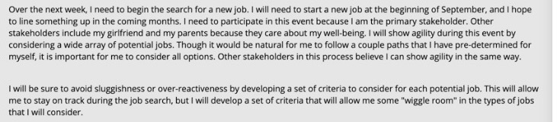
Event 4: Applying to a PhD program (by December for fall 2021). Study for gmat and work one year to get some work experience first.
Event 5: Helping my brother plan his wedding (next month)

